

A CAPSTONE PROJECT REPORT
On
PLANT LEAF DISEASE IDENTIFICATION AND CLASSIFICATION USING OPENCV AND MACHINE LEARNING
A Capstone Project Report submitted in partial fulfilment of the requirements
for the Course of
DSA0201- COMPUTER VISION WITH OPENCV
to the award of the degree of
BACHELOR OF TECHNOLOGY
IN
ARTIFICIAL INTELLIGENCE AND DATA SCIENCE
SUBMITTED BY
B. HEMANTH KUMAR (192324238)

SUPERVISED BY
Dr. M. MAYURANATHAN
SAVEETHA SCHOOL OF ENGINEERING,
SIMATS CHENNAI-602105
SEPTEMBER - 2025
SIMATS ENGINEERING
Saveetha Institute of Medical and Technical Sciences
Chennai-602105
CERTIFICATE FROM THE SUPERVISOR
This is to certify that the Capstone Project entitled “Plant Leaf Disease Identification and Classification using OpenCV and Machine Learning” has been carried out by Hemanth Kumar. B(192324238), Nandivardhan .P(192324270), K. V. Karthikeya(192324183) us under the supervision of Dr. M. MAYURANATHAN and is submitted in partial fulfilment of the requirements for the current semester of the B. Tech AI & DS program at Saveetha Institute of Medical and Technical Sciences, Chennai.

PROGRAM DIRECTOR | SUPERVISOR
Dr. A. Narenthirakumar, | Dr. M. Mayuranathan
Department of CSE | Department of CSE
Saveetha School of Engineering | Saveetha School of Engineering
SIMATS | SIMATS

INTERNAL EXAMINER EXTERNAL EXAMINER

SIMATS ENGINEERING
Saveetha Institute of Medical and Technical Sciences
Chennai-602105
DECLARATION
We, Hemanth Kumar. B(192324238), Nandivardhan .P(192324270),Karthikeya(192324183) Students of the Artificial Intelligence & Data Science, Saveetha Institute of Medical and Technical Sciences, Saveetha University, Chennai, hereby declare that the Capstone Project Work entitled “Plant Leaf Disease Identification and Classification using OpenCV and Machine Learning” is the result of our own bonafide efforts. To the best of our knowledge, the work presented herein is original, accurate, and has been carried out in accordance with principles of engineering ethics. and academic integrity. All sources, references, data, and other materials used in the project have been appropriately acknowledged. We further declare that the data, results, analysis, and findings presented in this report have not been fabricated, falsified, or manipulated. Any external tools, software, datasets, computational resources, or AI-assisted tools used during the project have been appropriately

Place: Chennai
Date: 26/08/2026

Signature of the Students with Names

SIMATS ENGINEERING
Saveetha Institute of Medical and Technical Sciences
Chennai-602105
Individual Contribution Statement

Student Name / Register No. | Specific Responsibilities | Design & Development Contribution | Testing & Analysis Contribution | Report Contribution | Approx. Contribution (%)
B. HEMANTH KUMAR  192324238 | Project demonstration and presentation; explaining the problem, objectives, workflow and outputs. | Supported preparation and demonstration of the computer-vision and ML workflow. | Presented testing/results and explained output behaviour during demonstration. | Prepared demonstration-related content and reflection. | 34%
NANDIVARDHN. P  192324270 | As per team allocation. | As per team allocation. | As per team allocation. | As per team allocation. | 33%
K. V. KARTHIKEYA  192324183 | As per team allocation. | As per team allocation. | As per team allocation. | As per team allocation. | 33%
Total |  |  |  |  | 100%

ABSTRACT

Early identification of plant leaf diseases plays a crucial role in improving agricultural productivity and minimizing crop losses. In guava cultivation, visual inspection is commonly used to detect diseases; however, this approach is subjective, time-consuming, and prone to human error. The primary objective of this capstone project is to design and implement an automated system for detecting and classifying guava leaf diseases using image processing and machine learning techniques.
The proposed system follows a structured pipeline consisting of leaf segmentation, lesion detection, feature extraction, and multi-class classification. Initially, the input leaf image is transformed into the HSV color space to isolate the leaf region from complex backgrounds through threshold-based segmentation and morphological refinement. Disease-affected areas are then identified using contour analysis and color-based filtering. From the extracted regions, statistical, texture, and geometric features including Gray-Level Co-occurrence Matrix (GLCM) parameters and shape descriptors are computed to represent the disease characteristics numerically. A Random Forest classifier is trained on these features to categorize the leaf into one of the predefined classes: Anthracnose, Healthy, Insect Bite, Scorch, or YLD.
The system additionally estimates infection severity by calculating the ratio of diseased area to total leaf area. Experimental evaluation demonstrates reliable classification performance, indicating the feasibility of integrating computer vision techniques into practical agricultural advisory systems.
Keywords : Plant disease detection; OpenCV; Machine Learning; Guava leaf; Random Forest

TABLE OF CONTENTS

Sl.  No | TITLE | PAGE  NO
I | CERTIFICATE FROM THE SUPERVISOR | II
II | DECLARATION BY THE CANDIDATE | III
III | INDIVIDUAL CONTRIBUTION STATEMENT | IV
IV | ABSTRACT | V
V | LIST OF FIGURES | VI
VI | LIST OF TABLES | VII
VII | LIST OF ABBREVIATIONS | VIII
1 | CHAPTER 1: Introduction
2 | CHAPTER 2: Literature Review
3 | CHAPTER 3: Engineering Design & Trade-offs, Sustainability,  Ethics, Safety, Risk & Security
4 | CHAPTER 4: Implementation, Testing & Results, Project  Management
5 | CHAPTER 5: Conclusion & Reflection
 | References
 | Appendices

LIST OF FIGURES
Figure No. | Figure Name | Page No.
1 | Module 1 – Color Space Transformation & Image Segmentation
2 | Module 2 – Disease Spot Extraction
3 | Module 3 – Feature Extraction Output
4 | Accuracy Comparison of Algorithms
5 | Module 5 – Visualization & Result Labeling
6 | Overall System Architecture Diagram
7 | Infection Percentage Formula

LIST OF TABLES
Table No. | Table Name | Page No.
1 | Comparison of Disease Spot Extraction Approaches
2 | Comparison of Classification Models
3 | Confusion Matrix

LIST OF ABBREVIATIONS / SYMBOLS
Symbol | Description | Unit
ROI | Region of Interest | —
HSV | Hue, Saturation, Value | —
GLCM | Gray-Level Co-occurrence Matrix | —
SVM | Support Vector Machine | —
CNN | Convolutional Neural Network | —
YLD | Yellow Leaf Disease | —

CHAPTER 1
INTRODUCTION AND ENGINEERING PROBLEM

1.1 Background Information
Agriculture remains one of the most critical sectors supporting global food security and economic stability. Among fruit crops, guava is widely cultivated due to its nutritional value and commercial importance. However, guava plants are highly susceptible to various leaf diseases such as Anthracnose, Scorch, Yellow Leaf Disease (YLD), and pest-related damage. These diseases significantly reduce crop yield and fruit quality if not detected at an early stage. Traditionally, disease identification relies on manual visual inspection by farmers or agricultural experts. This method is often subjective, inconsistent, and time-consuming, particularly in large-scale farming environments. With advancements in computer vision and machine learning, automated image-based disease detection systems have emerged as a promising solution to enhance accuracy, speed, and scalability in agricultural diagnostics.

1.2 Need for the Project
Agriculture remains one of the most critical sectors supporting global food security and economic stability. The source report identifies disease detection in guava cultivation as a significant application context and describes the limitations of manual visual inspection.

1.3 Problem Statement
Guava crops are frequently affected by various leaf diseases such as Anthracnose, Scorch, Yellow Leaf Disease (YLD), and insect-induced damage. These diseases often exhibit similar visual symptoms, including discoloration, lesions, and texture variations, making accurate identification challenging. Traditional disease detection methods rely primarily on manual observation by farmers or agricultural experts. This approach is subjective, prone to misinterpretation, and inefficient for large-scale farming operations. Delayed or incorrect diagnosis can lead to rapid disease spread, reduced fruit quality, and significant economic losses. Therefore, there is a clear need for a systematic, automated, and reliable method to detect and classify guava leaf diseases using computational techniques.

1.4 Project Aim
The primary aim of this capstone project is to design and implement an automated system capable of detecting and classifying guava leaf diseases using image processing and machine learning techniques.

1.5 Project Objectives
- To isolate the leaf region from complex backgrounds using color space transformation.
- To identify and extract diseased regions within the segmented leaf.
- To compute meaningful texture, shape, and color features from detected lesions.
- To train a multi-class classification model for disease prediction.
- To estimate the severity of infection based on the proportion of affected area.

1.6 Scope
The scope of this project is limited to detecting and classifying guava leaf diseases using static image inputs. The system processes leaf images, extracts relevant features, and predicts one of the predefined disease categories. It also calculates the percentage of infection based on lesion area analysis. However, the project does not include real-time field deployment, treatment recommendation systems, or integration with IoT devices. Additionally, performance depends on the quality and size of the available dataset.

1.7 Expected Engineering Outcome
The intended outcome is an automated system for guava leaf disease detection and classification, with infection severity estimation based on diseased area analysis.

CHAPTER 2
LITERATURE REVIEW AND EXISTING SOLUTIONS

2.1 Review Method
The source report identifies supporting research in computer vision and agricultural informatics, including GLCM texture features and machine-learning classification; it does not specify a separate literature-search database or protocol.

2.2 Review of Existing Work
Numerous studies in computer vision and agricultural informatics demonstrate the effectiveness of image processing and machine learning in plant disease detection. Research indicates that texture-based features such as Gray-Level Co-occurrence Matrix (GLCM) parameters can successfully distinguish between healthy and diseased leaf tissues. Additionally, ensemble machine learning models like Random Forest have shown strong performance in multi-class classification problems involving biological image data. Precision agriculture initiatives worldwide increasingly adopt AI-driven diagnostic tools to enhance crop monitoring and reduce yield losses. These findings validate the relevance and feasibility of developing an automated guava leaf disease classification system.

2.3 Comparative Analysis
Existing Approach | Advantages | Limitations | Relevance to Proposed Work
Edge-based contour detection | Detects boundaries | Detects veins, shadows, texture | Not color-specific for disease extraction
Generic contour detection | Simple shape extraction | Cannot distinguish brown lesions | Requires color-specific filtering
Heavy contour filtering | Can reduce noise | Produces noisy contours | HSV + contour filtering used instead

2.4 Research / Engineering Gap
Guava crops are frequently affected by various leaf diseases such as Anthracnose, Scorch, Yellow Leaf Disease (YLD), and insect-induced damage. These diseases often exhibit similar visual symptoms, including discoloration, lesions, and texture variations, making accurate identification challenging. Traditional disease detection methods rely primarily on manual observation by farmers or agricultural experts. This approach is subjective, prone to misinterpretation, and inefficient for large-scale farming operations. Delayed or incorrect diagnosis can lead to rapid disease spread, reduced fruit quality, and significant economic losses. Therefore, there is a clear need for a systematic, automated, and reliable method to detect and classify guava leaf diseases using computational techniques.

2.5 Proposed Contribution
If applicable, working with peers, supervisors, or mentors improved my communication and teamwork skills. Discussing design approaches and receiving feedback enhanced my ability to articulate technical ideas clearly. In situations where coordination was required, I learned the importance of structured communication, documentation, and collaborative problem-solving. These experiences highlighted the value of teamwork in engineering projects and reinforced the importance of professional interaction in technical environments.

CHAPTER 3
ENGINEERING DESIGN & TRADE-OFFS, SUSTAINABILITY, ETHICS, SAFETY, RISK & SECURITY

3.1 Requirements
The source report defines the core functional requirements through its solution pipeline: leaf segmentation, lesion detection, feature extraction, classification, and severity estimation.
Requirement | Type | Measurable Target
Leaf segmentation | Functional | Isolate leaf region from background
Disease spot detection | Functional | Identify diseased regions
Feature extraction | Functional | Compute texture, shape and color features
Classification | Functional | Predict predefined disease category
Severity estimation | Functional | Calculate infection percentage

3.2 Constraints & Applicable Standards
The project is an academic prototype and is limited to static image inputs; it does not include real-time field deployment, treatment recommendation systems, or IoT integration.
Standard / Code | Requirement | How Applied in This Project
IEEE 830/29148 | Requirement specification and documentation | Structured documentation practices
ISO 12207 | Software Life Cycle Processes | Requirement analysis, design, implementation, testing and validation
ISO/IEC 25010 | Software Quality Model | Reliability, maintainability, usability and performance
IEEE 1012 | Verification and Validation | Model evaluation metrics and confusion matrix validation

3.3 Design Specifications
Parameter | Target/Requirement | Unit | Priority
Color space | HSV | — | High
Feature set | Texture, shape, color | — | High
Classifier | Random Forest | — | High
Severity metric | Infected area / total leaf area | % | High

3.4 Alternative Solutions & Evaluation
Alternative 1: Random Forest classifier was used for multi-class disease prediction.
Alternative 2: Support Vector Machine (SVM) was considered as an alternative.
Criterion | Weight | Alternative 1 | Alternative 2
Performance |  | Random Forest – Better class separation | SVM – Good margin optimization
Cost
Safety
Sustainability
Reliability

3.5 Selected Design & Detailed Design
The implementation phase began with image preprocessing and color space transformation to isolate the leaf from complex backgrounds. Subsequently, disease-affected regions were identified using color-based filtering and contour analysis. Feature extraction techniques were applied to quantify texture, shape, and color characteristics of the detected lesions. These features were then normalized and used to train a multi-class machine learning model. Model performance was evaluated using standard metrics such as accuracy and confusion matrices. Based on evaluation results, parameters were fine-tuned to optimize classification performance. This systematic development cycle ensured reliability and clarity in the final system.
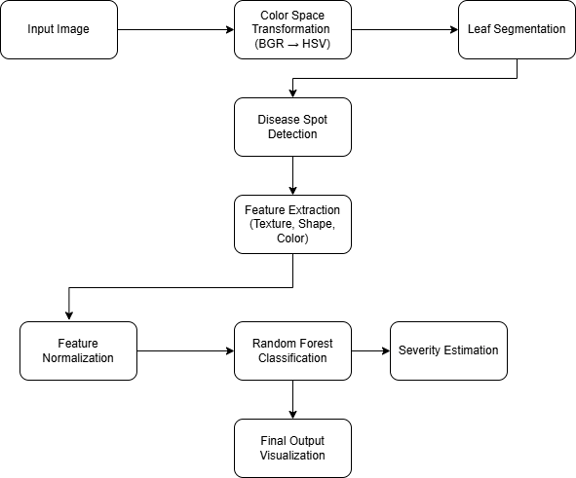
Figure: Overall System Architecture Diagram

3.6 Trade-off Analysis
Design Decision | Alternative Considered | Benefit | Disadvantage | Final Decision & Justification
Classifier selection | SVM | Good margin optimization | Alternative to selected model | Random Forest selected for better class separation
Disease spot extraction | Edge-based methods | Can detect boundaries | Detects veins, shadows and texture | HSV thresholding with contours selected

3.7 Sustainability, Ethics, Safety, Risk & Security
Domain | Consideration | Evidence Evaluated | Impact on Final Decision
Sustainability | Software-based image analysis | Static-image computational workflow | Supports scalable digital deployment
Ethics | Academic and engineering integrity | Source declaration and standards-based development | Structured documentation and validation
Health & Safety | No physical intervention in crops | Academic prototype scope | No direct field hazard introduced
Security | Controlled software/data workflow | Model and dataset handling | Supports maintainable prototype

Risk | Likelihood | Severity | Risk Level | Mitigation | Residual Risk
Lighting variation | Medium | Medium | Medium | HSV transformation and threshold tuning | Low
Similar disease appearance | Medium | High | High | Multiple feature types | Medium
Dataset imbalance | Medium | Medium | Medium | Balanced class weights and stratified splitting | Low
Small lesion detection | Medium | Medium | Medium | Threshold parameter tuning | Low

CHAPTER 4
IMPLEMENTATION, TESTING & RESULTS, PROJECT MANAGEMENT

4.1 Development Approach & Resources
The development of the proposed system followed a structured and iterative engineering approach. Initially, the problem was analyzed to identify the key functional requirements, including leaf segmentation, lesion detection, feature extraction, classification, and severity estimation. A modular architecture was then designed to ensure scalability and maintainability.
The source report identifies Python, OpenCV, NumPy, Scikit-learn, Matplotlib and optional Tkinter as the principal implementation resources.

4.2 Software Implementation & Modern Tools Used
These tools were selected due to their robustness, community support, and suitability for rapid prototyping in computer vision applications.
Tool / Software / Equipment | Purpose | Stage Used
Python Programming Language | Core implementation | All stages
OpenCV | Image processing, color conversion, thresholding, contours and morphology | Preprocessing / segmentation / visualization
NumPy | Numerical computations and arrays | Feature processing
Scikit-learn | Random Forest, scaling and evaluation | Classification
Matplotlib | Result visualization | Evaluation
Tkinter (Optional GUI) | Interactive output visualization | Interface

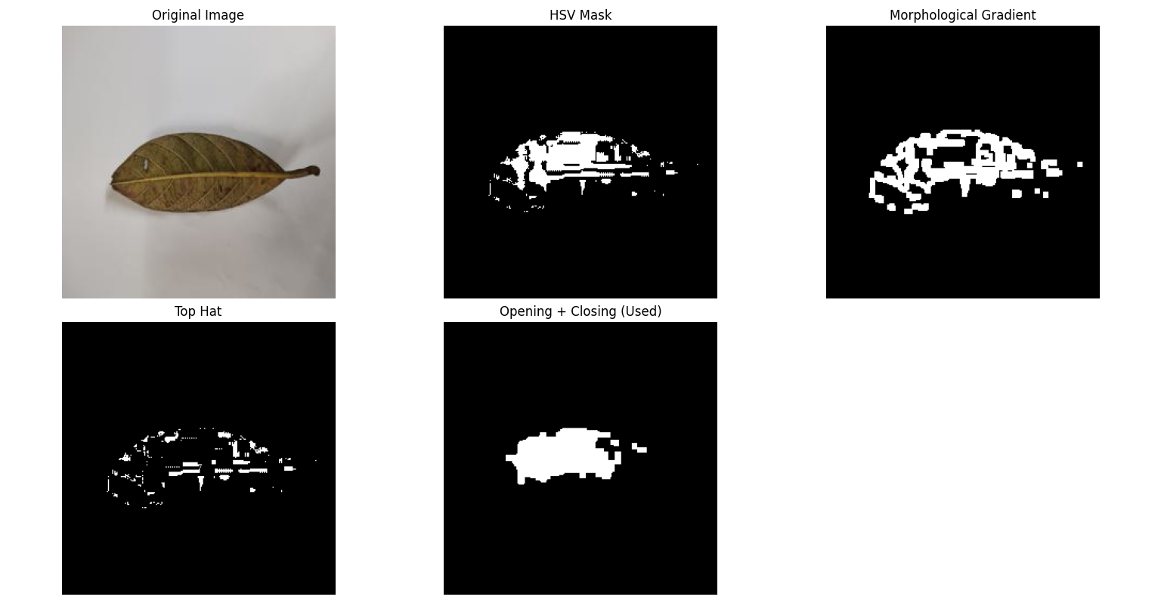
Figure: Module 1 – Color Space Transformation & Image Segmentation
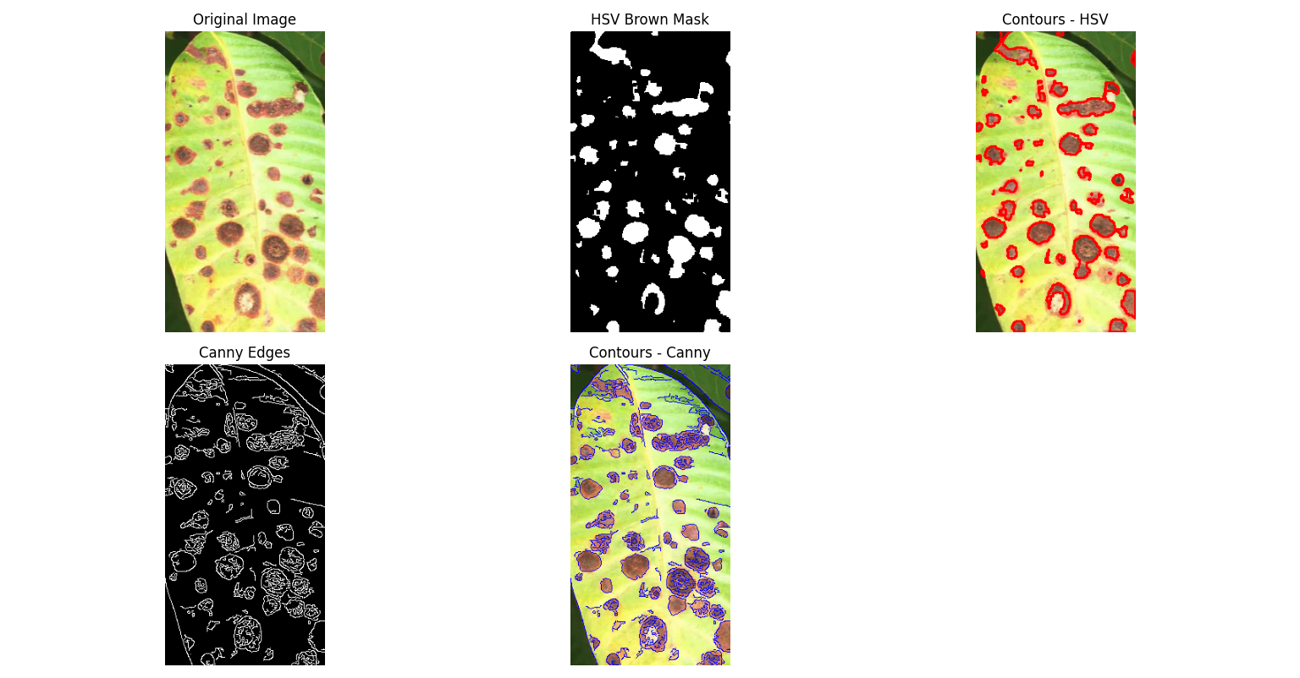
Figure: Module 2 – Disease Spot Extraction
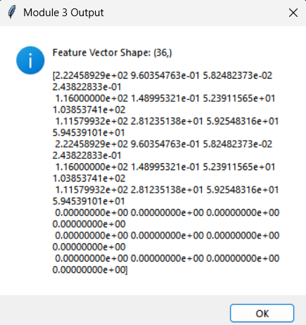
Figure: Module 3 – Feature Extraction Output
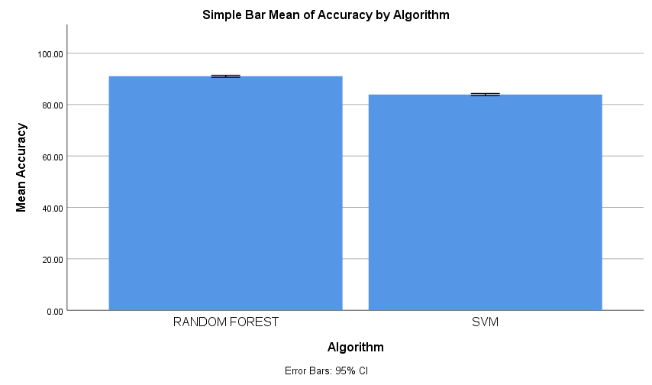
Figure: Accuracy Comparison of Algorithms
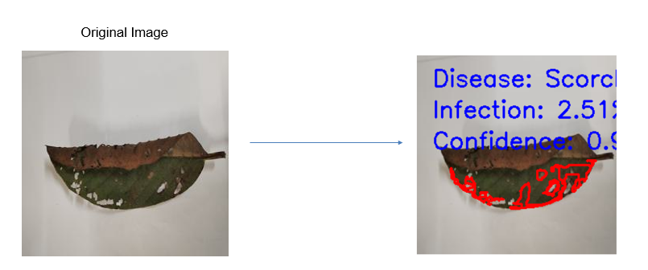
Figure: Module 5 – Visualization & Result Labeling

4.3 Test Plan & Verification
The performance of the proposed guava leaf disease detection system was evaluated using quantitative classification metrics and visual output validation. The Random Forest classifier was assessed using training and testing datasets with stratified sampling to ensure balanced representation of disease classes. The primary evaluation parameters included accuracy, precision, recall, F1-score, and confusion matrix analysis.
Requirement | Test Method | Acceptance Criterion
Leaf segmentation | Visual validation of segmented output | Leaf region isolated
Disease spot detection | Contour and color-mask inspection | Lesion regions detected
Classification | Training/testing evaluation | Reliable multi-class prediction
Severity estimation | Area-ratio calculation | Infection percentage generated

4.4 Results
The experimental results demonstrated that the system achieved reliable classification performance across multiple disease categories. The feature engineering approach, combining texture (GLCM), shape, and color descriptors, effectively captured discriminative characteristics of diseased and healthy leaves. The infection severity estimation, calculated as the ratio of infected area to total leaf area, provided an interpretable and practical metric for assessing disease progression.
The segmentation and contour detection stages successfully isolated most lesion regions, enabling accurate feature extraction. Overall, the integrated pipeline effectively addressed the initial problem of automated guava leaf disease identification with satisfactory performance under controlled image conditions.

4.5 Data Analysis & Engineering Judgment
The results indicate that combining texture (GLCM), shape, and color descriptors provided discriminative information for classification. Segmentation and contour detection isolated most lesion regions, while infection severity offered an interpretable measure of affected area. The report notes that iterative testing and parameter tuning progressively minimized observed challenges.

4.6 Comparison with Existing Solutions & Achievement of Objectives
Objective | Evidence | Achievement (Fully/Partially/Not Achieved)
Isolate leaf region | HSV segmentation and morphological refinement | Fully
Identify diseased regions | Color masking and contour extraction | Fully
Compute texture, shape and color features | GLCM and geometric/statistical descriptors | Fully
Train multi-class model | Random Forest classifier | Fully
Estimate infection severity | Diseased-area ratio | Fully

4.7 Strengths & Limitations
Strengths: Integrated image-processing and machine-learning pipeline; interpretable infection severity metric; modular implementation; structured validation.
Limitations: Performance depends on image quality and dataset size; lighting variations affect segmentation; similar disease appearance can cause classification difficulty; real-time field deployment is outside the project scope.

4.8 Project Planning, Roles & Budget
Student | Assigned Responsibility | Actual Contribution
B. HEMANTH KUMAR (192324238) | [As documented in individual contribution statement] | [To be completed]
P. NANDIVARDHAN (192324270) | [As documented in individual contribution statement] | [To be completed]
K. V. KARTHIKEYA (192324183) | [As documented in individual contribution statement] | [To be completed]

Item | Estimated Cost | Actual Cost
Software / development resources | — | —
Dataset / image resources | — | —
Total | — | —

CHAPTER 5
CONCLUSION & REFLECTION

5.1 Conclusion
This capstone project addressed the challenge of accurately identifying guava leaf diseases using automated computational techniques. Traditional manual disease detection methods are often inconsistent, time-consuming, and dependent on expert knowledge. To overcome these limitations, an image processing and machine learning-based system was developed to classify guava leaf conditions into multiple categories, including Anthracnose, Healthy, Insect Bite, Scorch, and Yellow Leaf Disease (YLD).
The proposed solution implemented a structured processing pipeline consisting of leaf segmentation, lesion detection, feature extraction, feature normalization, and multi-class classification using a Random Forest model. Texture, shape, and color features were systematically extracted to represent disease characteristics numerically. Additionally, infection severity was calculated by estimating the proportion of diseased area relative to the total leaf area. Experimental evaluation demonstrated that the integrated approach provides reliable classification performance and interpretable results.
The value of this project lies in its practical applicability to precision agriculture. By combining engineering principles with agricultural needs, the system demonstrates how computer vision and machine learning can assist farmers in early disease detection and decision-making. Beyond academic fulfillment, this project highlights the potential of technology-driven solutions in improving crop management and reducing economic losses. Overall, the study contributes to the advancement of intelligent agricultural monitoring systems and establishes a foundation for future enhancements and real-world deployment.

5.2 Future Work
- Implementing deep learning models such as Convolutional Neural Networks (CNNs) to automatically learn hierarchical features.
- Increasing dataset size and diversity to improve generalization under varying environmental conditions.
- Incorporating color normalization techniques to further reduce illumination sensitivity.
- Developing multi-label classification capability to handle leaves affected by multiple diseases simultaneously.
- Optimizing segmentation using advanced methods such as k-means clustering or adaptive thresholding.
These enhancements could significantly improve system robustness and real-world applicability.

5.3 Professional Learning & Individual Reflection

5.3.1 Academic Knowledge
Throughout the development of this capstone project, I gained a deeper understanding of key concepts in image processing, computer vision, and machine learning. The project required practical application of theoretical principles such as color space transformation, feature extraction using Gray-Level Co-occurrence Matrix (GLCM), contour-based shape analysis, and ensemble learning methods like Random Forest classification. Implementing these concepts in a real-world agricultural context strengthened my comprehension of how mathematical models and algorithms are translated into functional systems. This project bridged the gap between theoretical coursework and practical engineering implementation, enhancing my confidence in applying academic knowledge to solve real-world problems.

5.3.2 Technical Skills
The project significantly improved my technical proficiency, particularly in Python programming and the use of specialized libraries such as OpenCV, NumPy, and Scikit-learn. I developed hands-on experience in image preprocessing, data normalization, model training, evaluation, and GUI development. Additionally, I gained experience in dataset handling, debugging complex code errors, optimizing parameters, and interpreting model performance metrics. The process of building a modular and structured system strengthened my ability to design maintainable and scalable software solutions.

5.3.3 Problem-Solving and Critical Thinking
Developing this system required continuous analytical thinking and iterative problem-solving. Challenges such as segmentation inaccuracies, misclassification between similar diseases, and dataset imbalance demanded careful evaluation and adjustment of thresholds, feature combinations, and model parameters. I learned to systematically identify the root cause of errors and apply logical reasoning to refine the solution. This experience improved my ability to approach complex technical problems methodically and develop efficient solutions under constraints.

5.3.4 Personal and Professional Growth
During the project, I faced several technical obstacles, including inconsistent image quality, feature mismatches, and model performance issues. There were moments of uncertainty when classification results were inaccurate or when errors occurred during implementation. Overcoming these difficulties required patience, persistence, and continuous learning. These challenges strengthened my resilience, adaptability, and confidence in handling complex engineering tasks independently.

5.3.5 Collaboration and Communication
If applicable, working with peers, supervisors, or mentors improved my communication and teamwork skills. Discussing design approaches and receiving feedback enhanced my ability to articulate technical ideas clearly. In situations where coordination was required, I learned the importance of structured communication, documentation, and collaborative problem-solving. These experiences highlighted the value of teamwork in engineering projects and reinforced the importance of professional interaction in technical environments.

5.3.6 Application of Engineering Standards
The project emphasized the importance of following structured engineering practices, including systematic requirement analysis, modular design, testing, and validation. By adhering to software development best practices and evaluation standards, the project achieved clarity, maintainability, and reliability. Applying validation techniques such as accuracy measurement, confusion matrix analysis, and performance evaluation ensured that the solution met quality expectations. This experience reinforced the significance of engineering discipline and structured development processes in achieving dependable results.

5.3.7 Insights into the Industry
This project provided valuable exposure to how computer vision and artificial intelligence are applied in modern agriculture. It demonstrated how technology can address real-world problems and contribute to precision farming practices. I gained insight into the interdisciplinary nature of engineering solutions, where software development, data analysis, and domain knowledge must integrate seamlessly. Understanding the practical considerations of deployment, scalability, and usability gave me a clearer perspective on industry expectations and professional standards.

5.3.8 Conclusion of Personal Development
The capstone project has been a transformative academic and professional experience. It enhanced my technical expertise, strengthened my analytical thinking, and improved my confidence in designing end-to-end engineering solutions. The project not only expanded my skill set but also clarified my interest in applying machine learning and computer vision to real-world challenges. Overall, this experience has better prepared me for future professional opportunities and motivated me to continue exploring advanced technologies within my field.

REFERENCES
• Barbedo, J. G. A. (2019). Plant disease identification from individual lesions and spots using deep learning. Biosystems Engineering, 180, 96–107.
• Ferentinos, K. P. (2018). Deep learning models for plant disease detection and diagnosis. Computers and Electronics in Agriculture, 145, 311–318.
• Kamilaris, A., & Prenafeta-Boldú, F. X. (2018). Deep learning in agriculture: A survey. Computers and Electronics in Agriculture, 147, 70–90.
• Khan, A., Sohail, A., Zahoora, U., & Qureshi, A. S. (2020). A survey of the recent architectures of deep convolutional neural networks. Artificial Intelligence Review, 53(8), 5455–5516.
• Liu, B., Zhang, Y., He, D., & Li, Y. (2020). Identification of apple leaf diseases based on deep convolutional neural networks. Symmetry, 12(2), 1–14.
• Mohanty, S. P., Hughes, D. P., & Salathé, M. (2016). Using deep learning for image-based plant disease detection. Frontiers in Plant Science, 7, 1419.
• Picon, A., Alvarez-Gila, A., Seitz, M., Ortiz-Barredo, A., Echazarra, J., & Johannes, A. (2019). Deep convolutional neural networks for mobile capture device-based crop disease classification in the wild. Computers and Electronics in Agriculture, 161, 280–290.
• Saleem, M. H., Potgieter, J., & Arif, K. M. (2020). Plant disease detection and classification by deep learning. Plants, 9(11), 1451.
• Singh, V., Misra, A. K., & Yadav, S. (2021). Plant leaf disease detection using machine learning techniques: A review. Multimedia Tools and Applications, 80, 29531–29553.
• Too, E. C., Yujian, L., Njuki, S., & Yingchun, L. (2019). A comparative study of fine-tuning deep learning models for plant disease identification. Computers and Electronics in Agriculture, 161, 272–279.

APPENDICES
The appendices provide supplementary material that supports the implementation, analysis, and documentation of the project. These materials enhance understanding of the system design and technical development.

Appendix A: Dataset Structure
The dataset used in this project consists of categorized guava leaf images organized into five classes:
- Anthracnose
- Healthy
- Insect_bite
- Scorch
- YLD
Each folder contains labeled images used for training and testing the classification model.

Appendix B: System Architecture Diagram
The overall system follows a sequential processing pipeline:

Figure: System Architecture Diagram

Appendix C: Core Code Snippets
1. Leaf Segmentation (HSV Thresholding)
hsv = cv2.cvtColor(image, cv2.COLOR_BGR2HSV)
mask = cv2.inRange(hsv, lower_green, upper_green)
2. Feature Extraction (GLCM Example)
glcm = graycomatrix(gray, distances=[1], angles=[0],
levels=256, symmetric=True, normed=True)
contrast = graycoprops(glcm, 'contrast')[0, 0]
3. Classification (Random Forest)
model = RandomForestClassifier(n_estimators=500,
max_depth=20,
class_weight='balanced')
model.fit(X_train, y_train)

Appendix D: Mathematical Formulations
Circularity Formula:
Standardization Formula:
Infection Percentage:
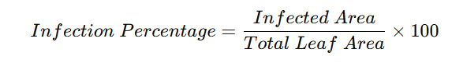
Figure: Infection Percentage Formula

Appendix E: Confusion Matrix
Actual \ Predicted | Anthracnose | Healthy | Insect_bite | Scorch | YLD
Anthracnose | XX | X | X | X | X
Healthy | X | XX | X | X | X
Insect_bite | X | X | XX | X | X
Scorch | X | X | X | XX | X
YLD | X | X | X | X | XX

Appendix F: User Guide
Steps to Run the System:
- Install dependencies: pip install -r requirements.txt
- Train the model: python train_model.py
- Run prediction: python main.py
- Use GUI: python gui_app.py

Appendix G: Sample Output
- Segmented leaf mask
- Detected lesion contours
- Feature vector values
- Predicted disease with confidence score
- Infection percentage visualization

